UNITED STATES

SECURITIES AND EXCHANGE COMMISSION

WASHINGTON, D.C. 20549

FORM 6-K

REPORT OF FOREIGN PRIVATE ISSUER

PURSUANT TO RULE 13a-16 OR 15d-16 UNDER

THE SECURITIES EXCHANGE ACT OF 1934

For the month of May 2026

Commission File Number: 001-40210

Tuya Inc.

10/F, Building A, Huace Center

Xihu District, Hangzhou City

Zhejiang, 310012

People’s Republic of China

(Address of principal executive offices)

Indicate by check mark whether the registrant files or will file annual reports under cover of Form 20-F or Form 40-F.

Form 20-F ☒ Form 40-F ☐

EXPLANATORY NOTE

We submitted next day disclosure return forms dated May 14, 15, 18, 19 and 20, 2026, respectively, to The Stock Exchange of Hong Kong Limited in relation to the changes in our issued share capital and/or share buybacks.

For details, please refer to the exhibits to this current report on Form 6-K.

2

 |  |  | EXHIBIT INDEX
Exhibit No. |  |  | Description
99.1 |  |  | Next Day Disclosure Return Dated May 14, 2026
99.2 |  |  | Next Day Disclosure Return Dated May 15, 2026
99.3 |  |  | Next Day Disclosure Return Dated May 18, 2026
99.4 |  |  | Next Day Disclosure Return Dated May 19, 2026
99.5 |  |  | Next Day Disclosure Return Dated May 20, 2026
 |  | 3

SIGNATURES

Pursuant to the requirements of the Securities Exchange Act of 1934, the registrant has duly caused this report to be signed on its behalf by the undersigned, thereunto duly authorized.

Tuya Inc.
By | : /s/ Yi (Alex) Yang
Name | : | Yi (Alex) Yang
Title | : Chief Financial Officer
Date: May 20, 2026
4

Exhibit 99.1
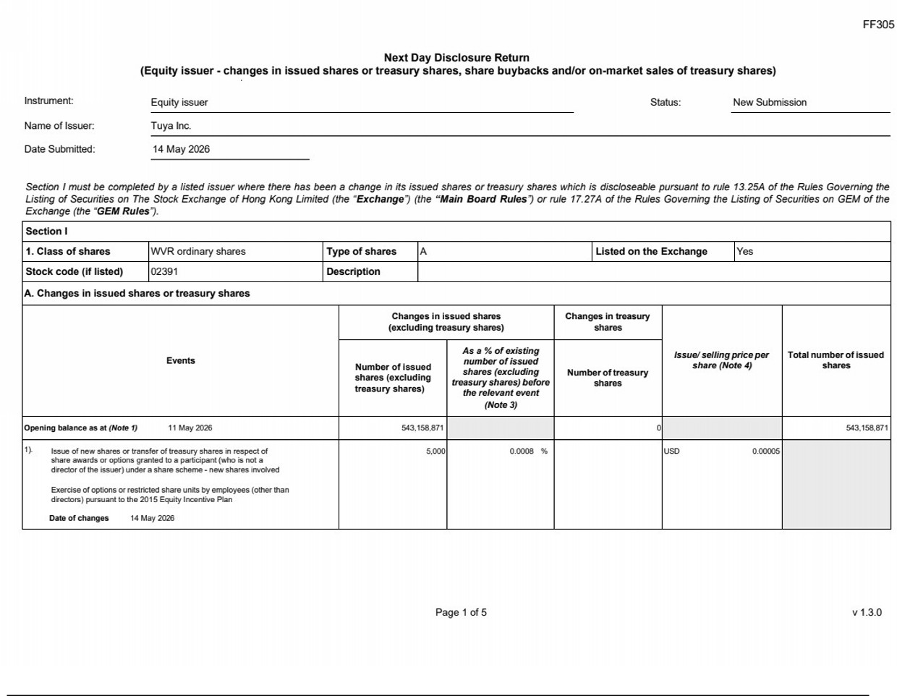

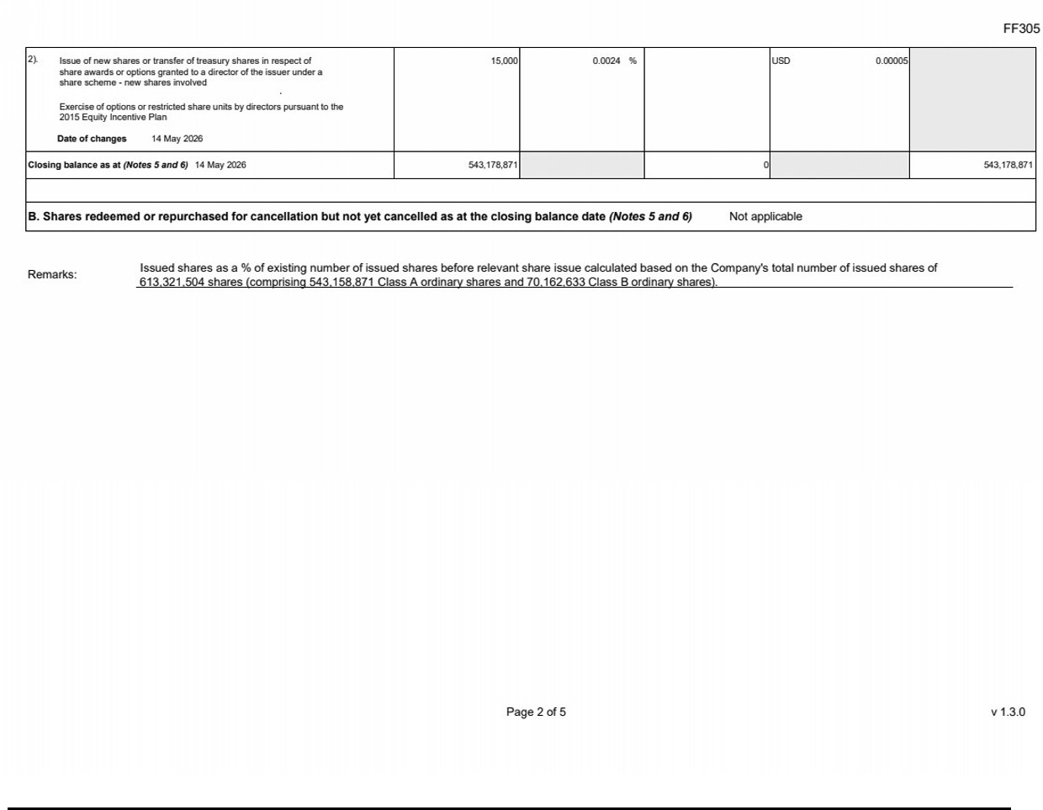

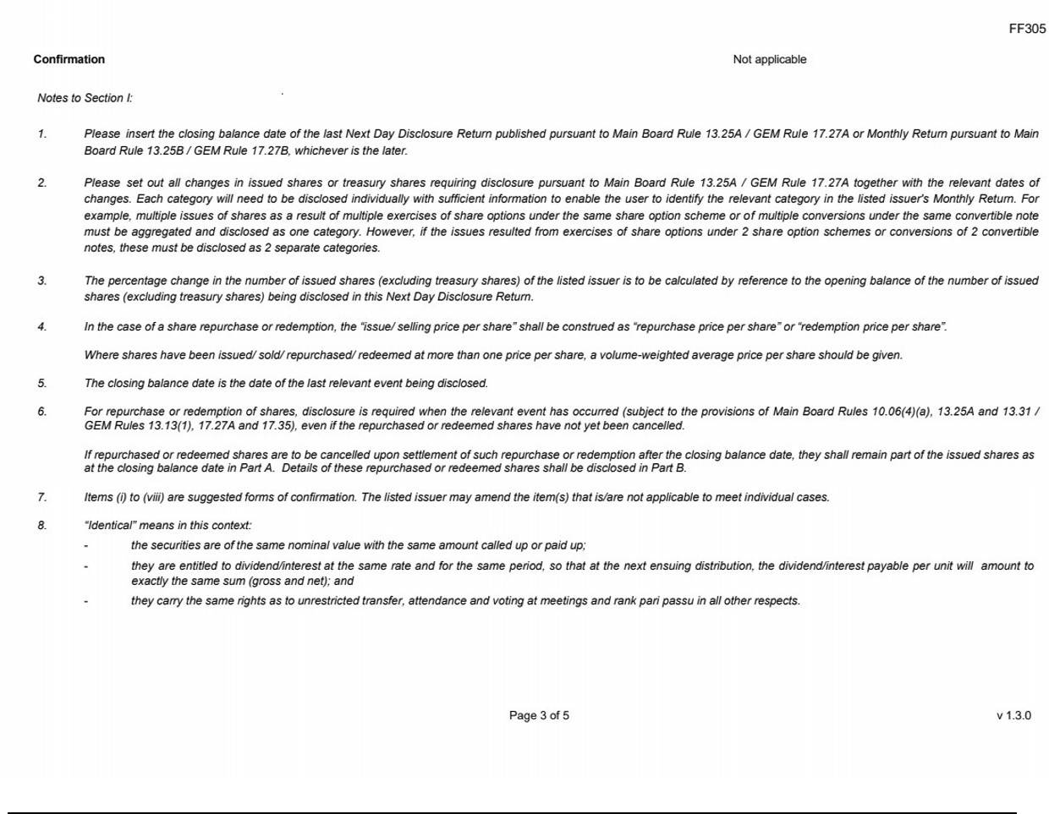

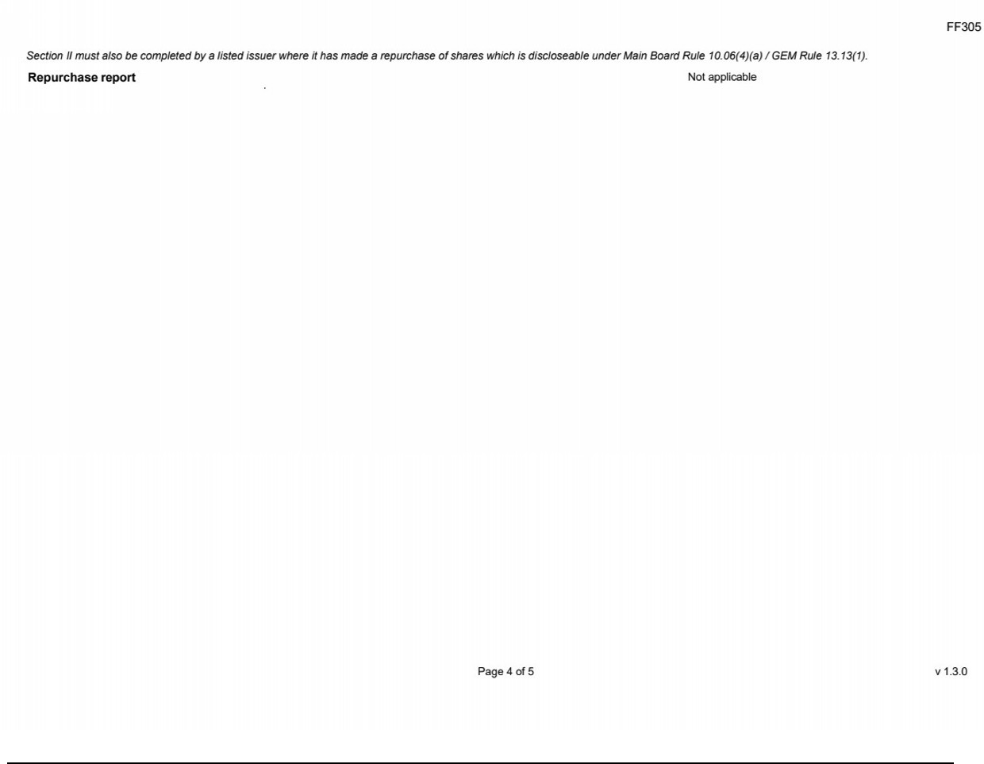

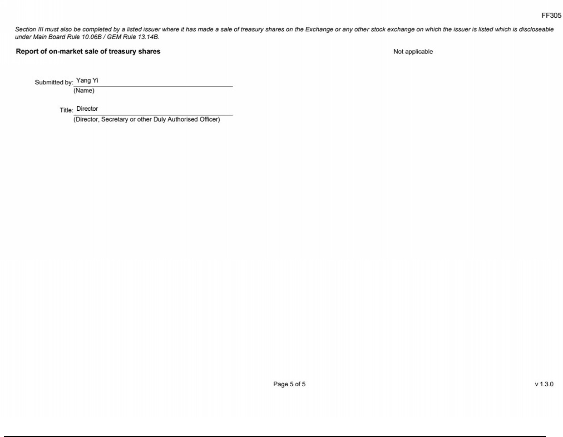

Exhibit 99.2
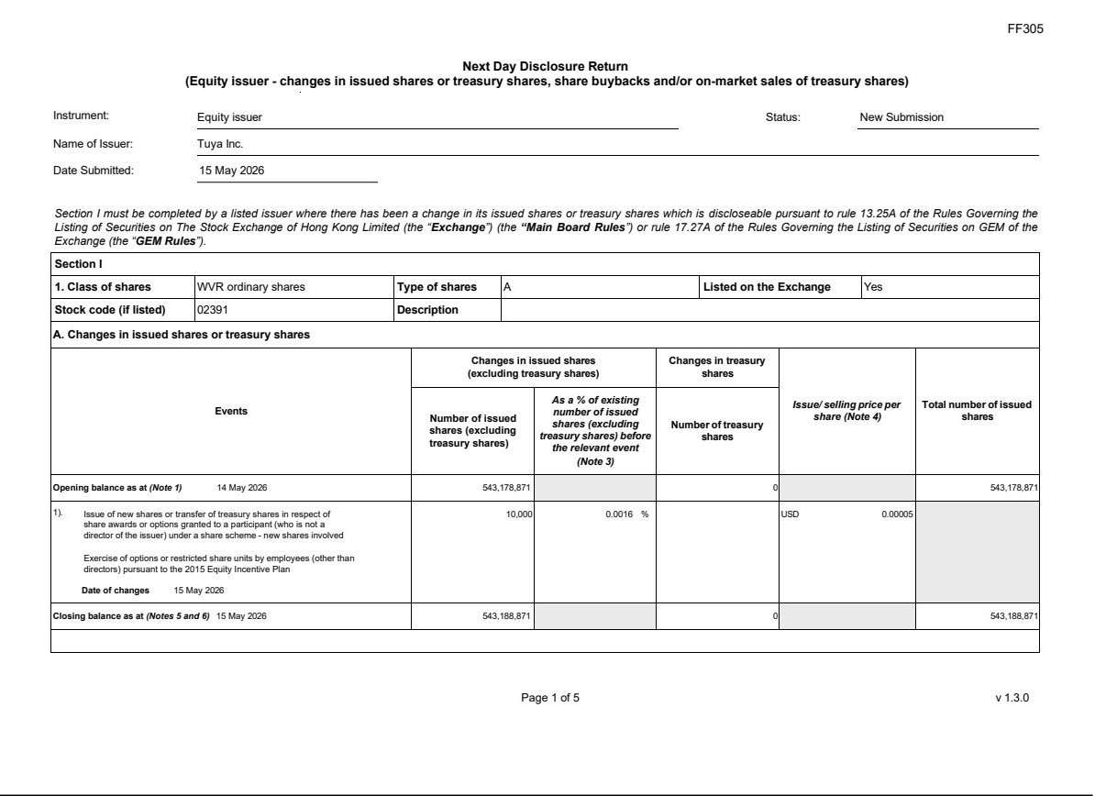

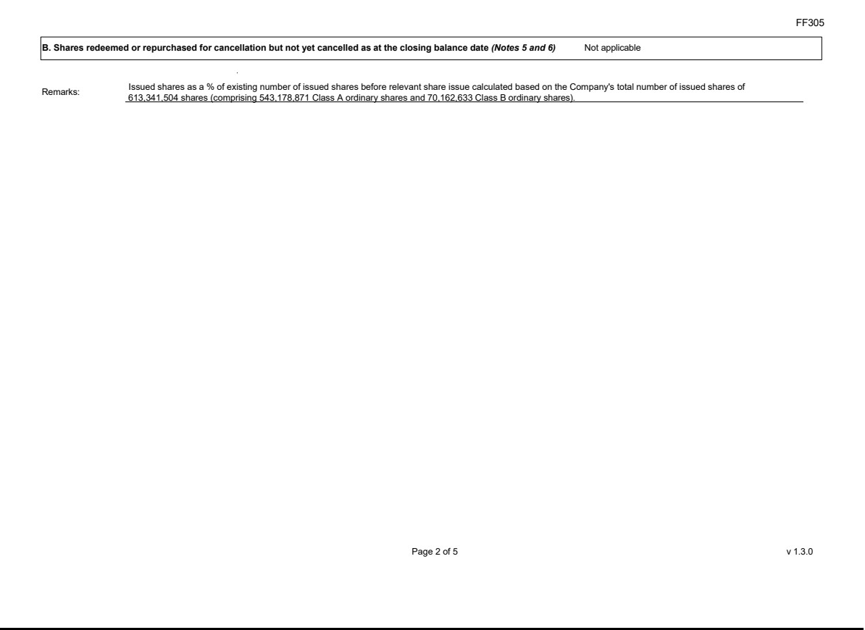

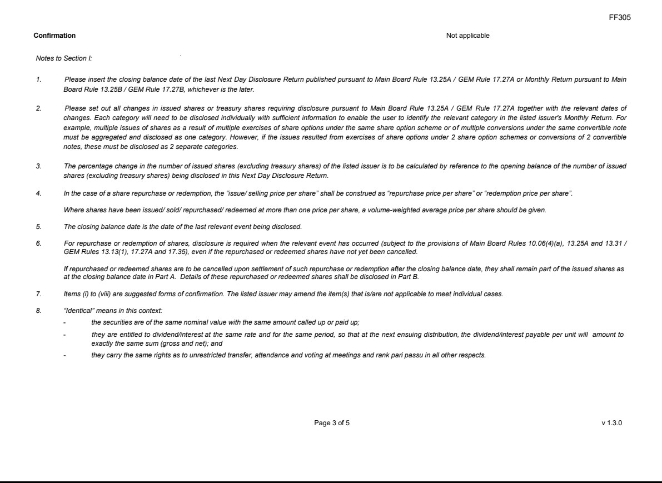

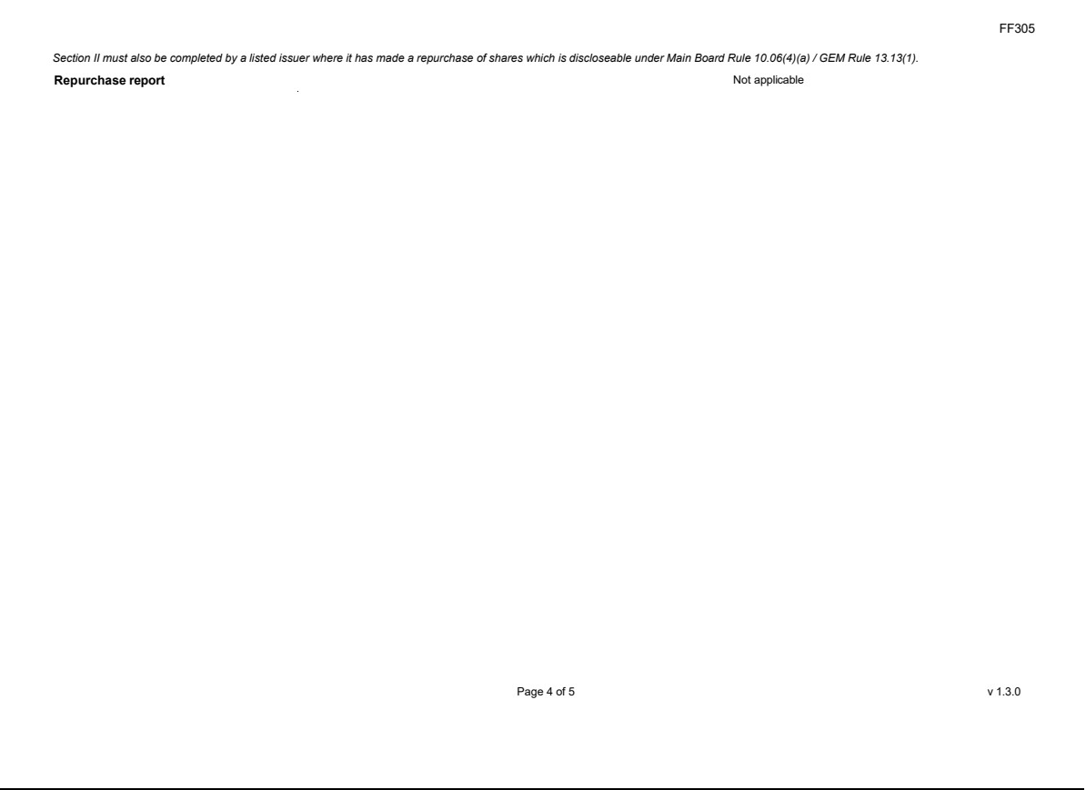

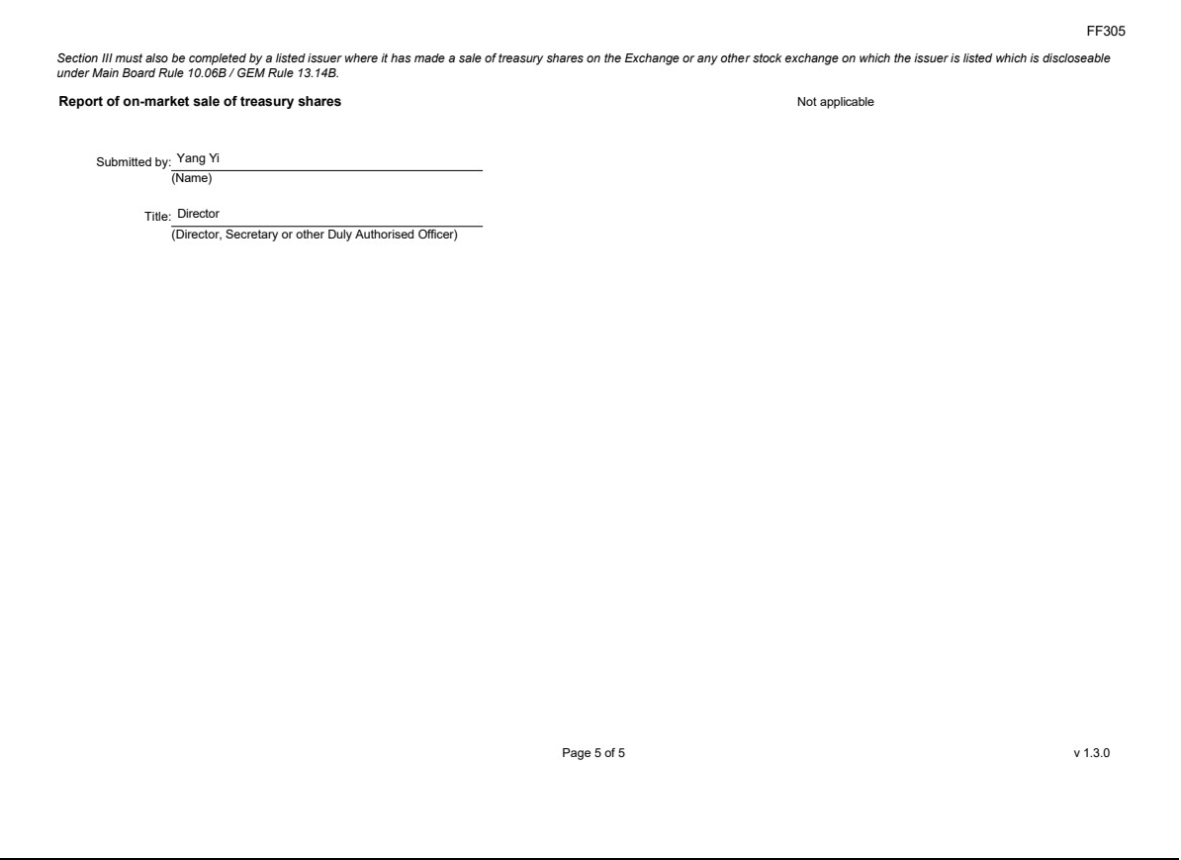

Exhibit 99.3
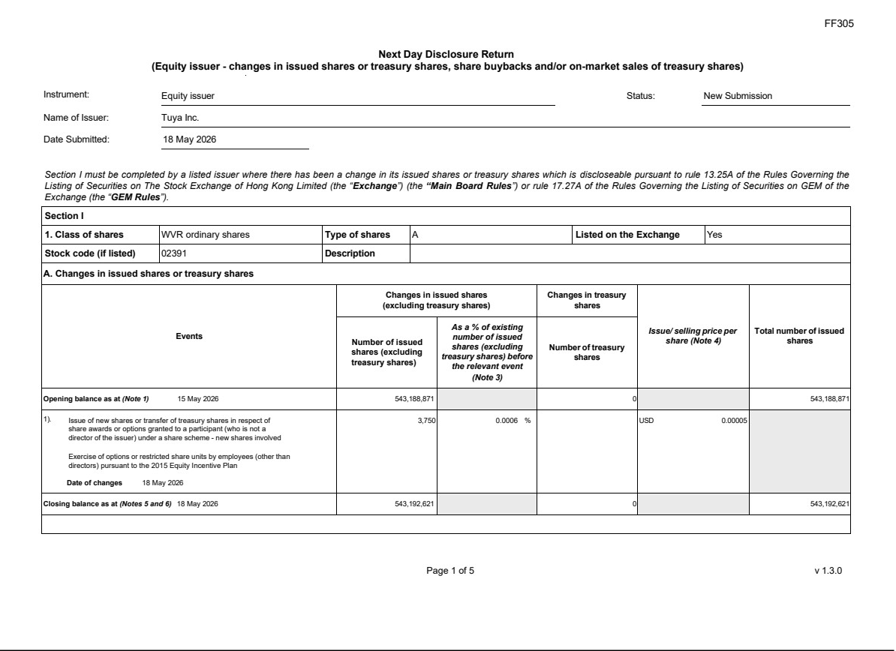

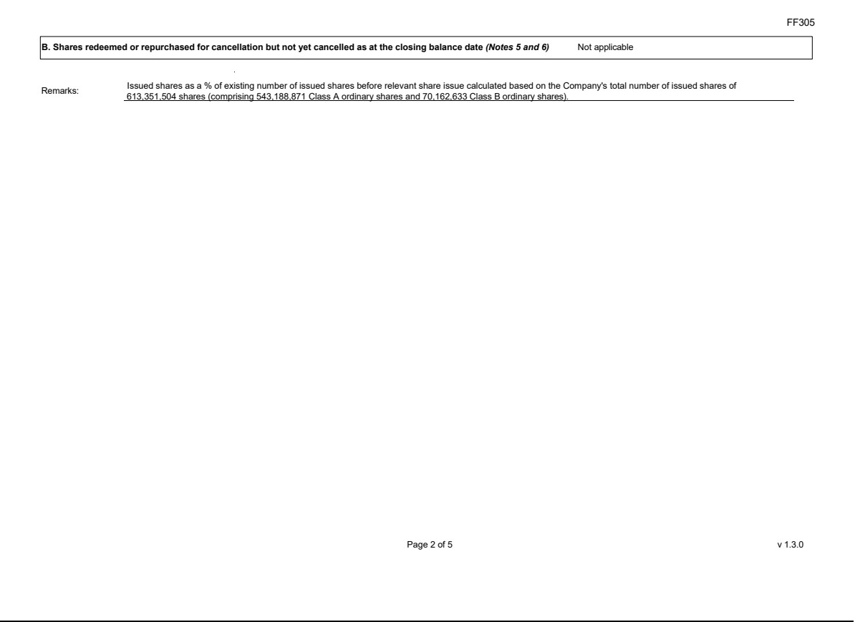

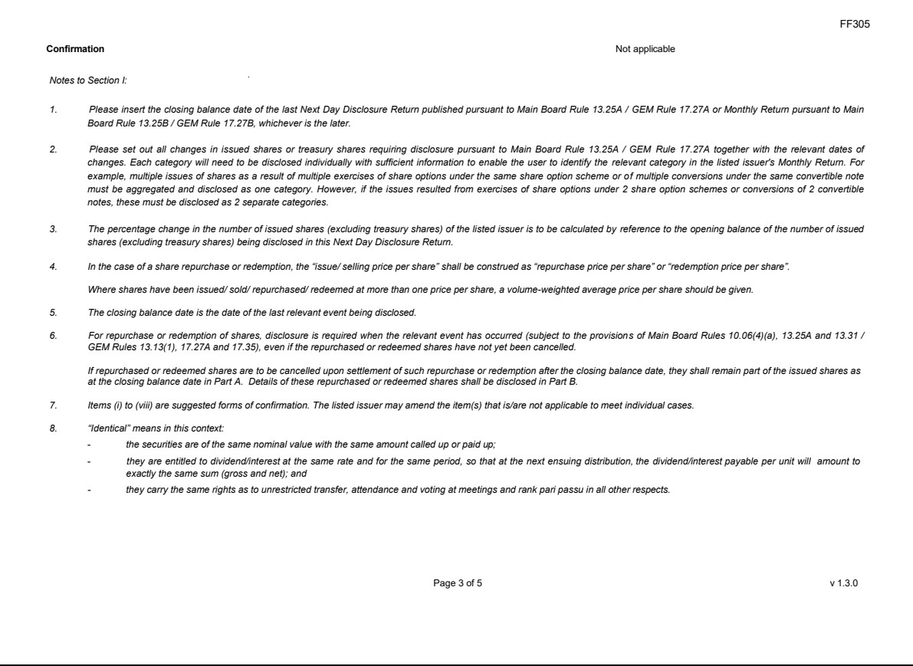

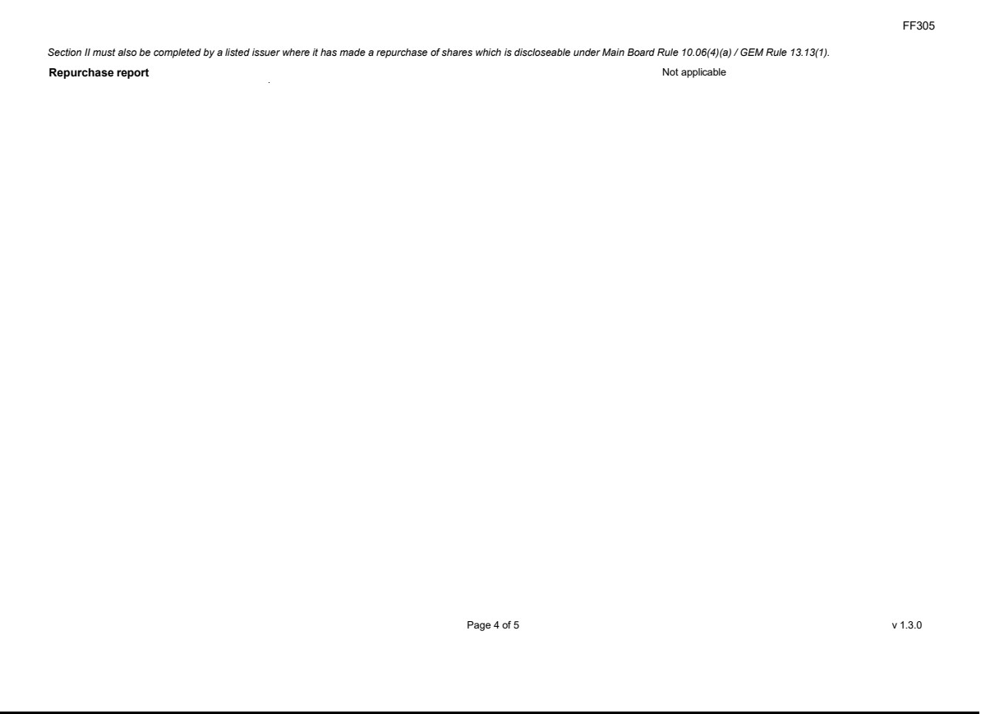

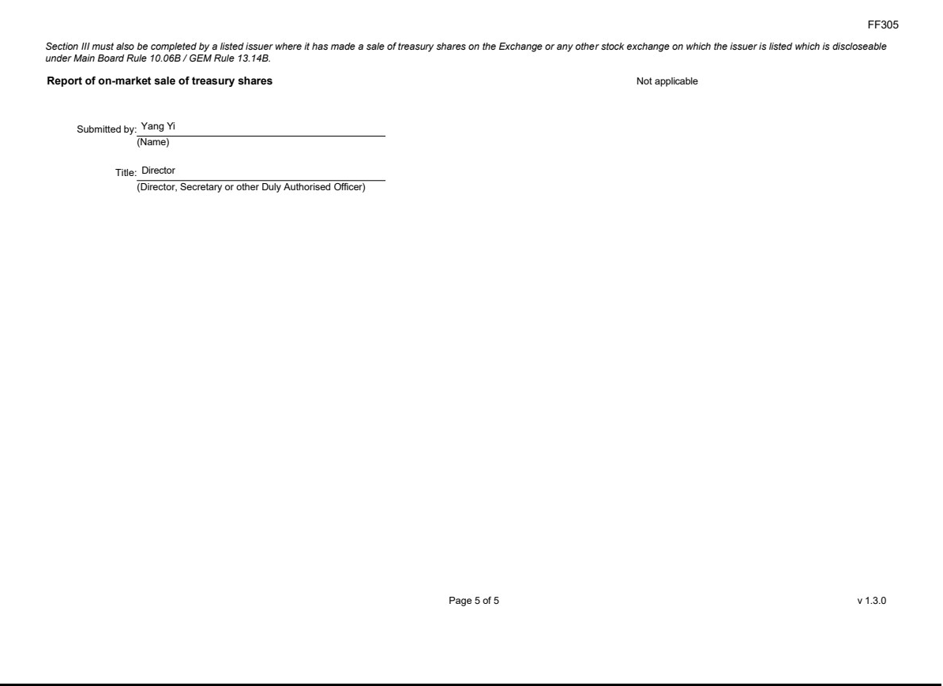

Exhibit 99.4
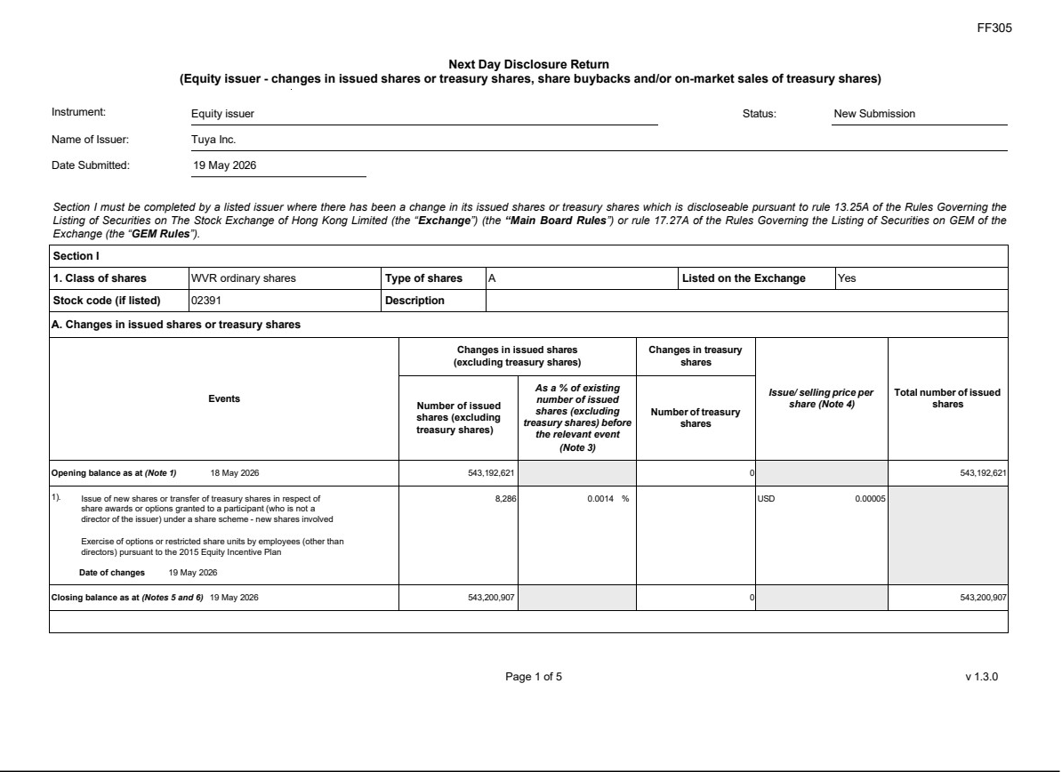

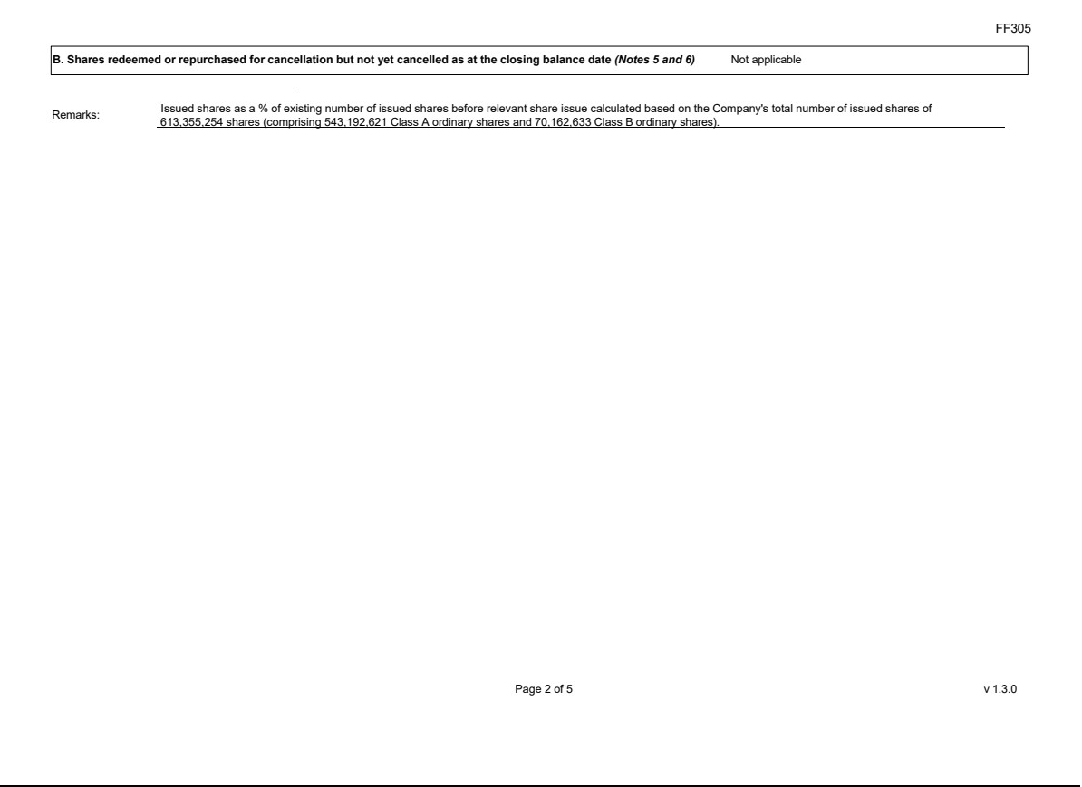

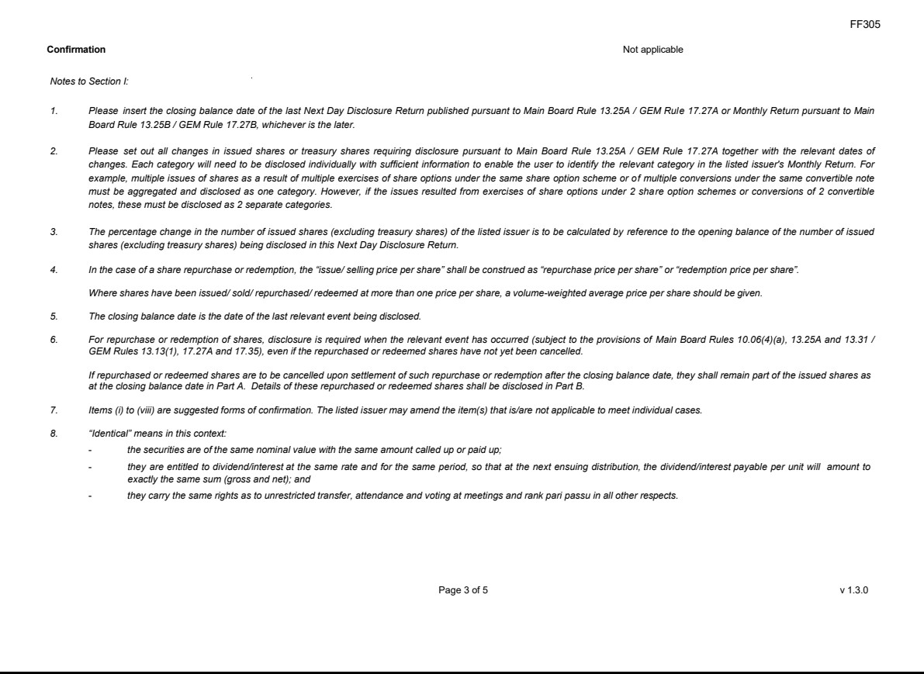

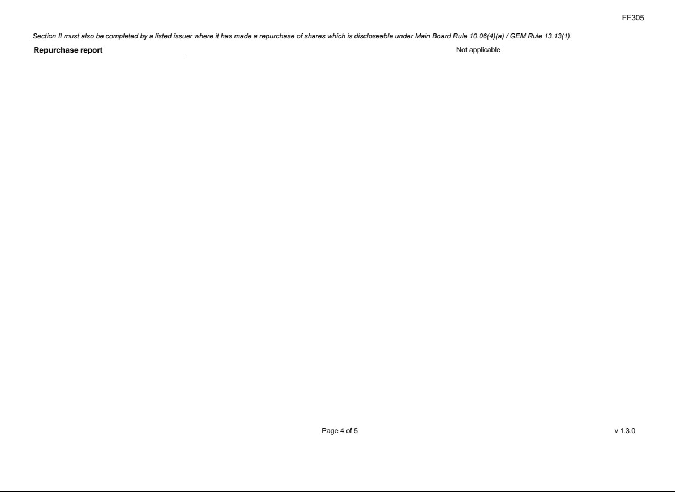

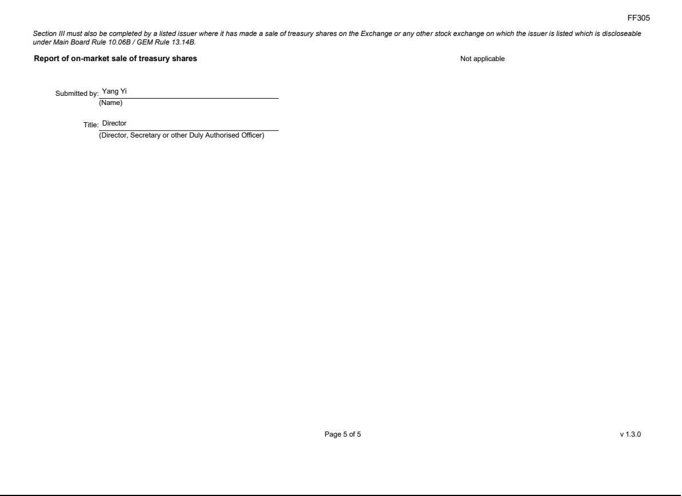

Exhibit 99.5


